# Introduction

Jimmy Blackburn, the Director of Operations at Big Mountain Resort, has requested this report from the data science team to examine the resort’s current pricing strategy and to propose a better ticket pricing model that will provide guidance on whether implementing certain operational changes will cut costs without undermining ticket price or support an even higher ticket price. The resort recently installed an additional chair lift which increased operating costs by $1,540,000 this season. The pricing model in this report was developed by the data science team based on data provided by Alesha Eisen, Database Manager, containing information from 330 resorts in the United States that can be considered part of the same market share. In this report, recommendations are made to increase Adult Weekend ticket price and propose scenarios to explore operational changes impacting ticket price.

# Findings

## Data Methods

After cleaning the provided United States resort data, we had information on 277 resorts and 25 of their facilities. We added state-wide summary statistics to represent resort density and the skiing competitive landscape of each state.

## Data Analysis and Results

We used the random forest regression model with 5-fold cross-validation to fit the data and found 8 features to have the highest impact on ticket price; in each category, Big Mountain Resort has positioned itself as a market leader.

Figure 1

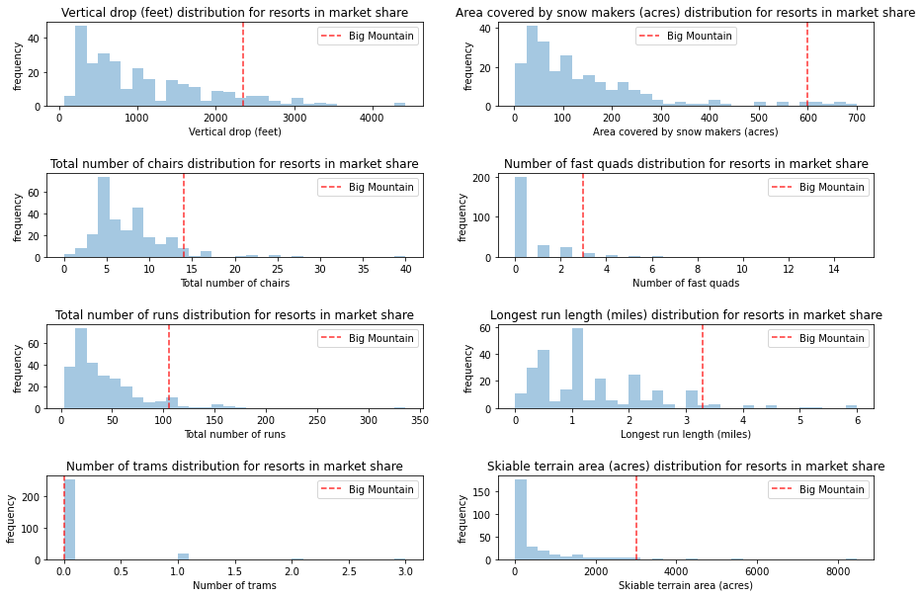

Using these features, the ticket pricing model proposed a price ($95.87) higher than Big Mountain Resort’s existing price ($81), since Big Mountain Resort’s top-notch facilities support a price commensurate with that quality. Even with the modelling’s expected mean absolute error of $10.39, this suggests there is room for a ticket price increase.

Figure 2

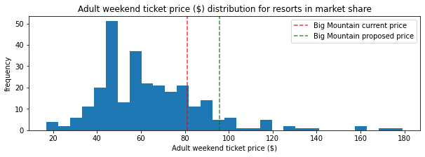

Using this pricing model, we were also able to run various scenarios where we explored how operational changes impacted would affect ticket price. We found the following 2 scenarios to be worth further investigation.

### Scenario 1: Permanently shut down up to 10 of the least used runs

The model says that closing 1 run has no impact on price. Closing 2 and 3 runs successively reduces support for ticket price and so revenue (assuming that each visitor, on average, buys 5 tickets, closing the 2nd run would reduce revenue by approximately $710,045, and closing the 3rd run would reduce revenue by approximately $1,166,667). After shutting down 3 runs, the shutdown of the consecutive 4th and 5th runs results in no further loss in ticket price.

Figure 3

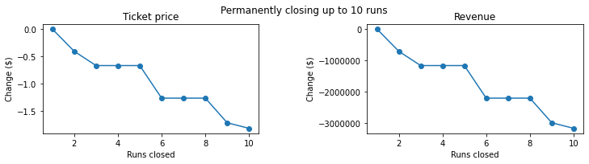

### Scenario 2: Increase vertical drop by 150 feet by adding a run and an additional chair lift

The model suggests that this scenario increases support for ticket price by $1.99. Thus, assuming that each visitor, on average, buys 5 tickets, this would amount to an increase in revenue of $3,474,638 over the season.

# Recommendations

## Ticket Price

Big Mountain Resort should increase its Adult Weekend ticket from $81 to $95.87.

## Scenarios

### Scenario 1: Permanently shut down up to 10 of the least used runs

Given the data, the resort should first shut down the least used run and evaluate the impact on revenue, expected to be negligible. If all goes accordingly, the resort could then try closing the 2nd run.

### Scenario 2: Increase vertical drop by 150 feet by adding a run and an additional chair lift

An expected increase in revenue of $3,474,638, in conjunction with additional chair lift operating costs of $1,540,000, would result in expected profit of nearly $2M. This scenario appears to be a clear profit-maker!